Name ____Tim Kwist_________________________ Date ___November 21, 2014_______
Laboratory 12: Cover Sheet

Section _________________________________________

Place a check mark in the Assigned column next to the exercises your instructor has assigned to you. Attach this cover sheet to the front of the packet of materials you submit following the laboratory.

Activities | Assigned: Check or list exercise numbers | Completed
Implementation Testing | ✓
Programming Exercise 1
Programming Exercise 2
Programming Exercise 3
Analysis Exercise 1
Analysis Exercise 2
 | Total

Name __________________________________________ Date _______________________
Laboratory 12: Implementation Testing

Section _________________________________________

Check with your instructor whether you are to complete this exercise prior to your lab period or during lab.

Test Plan 12-1 (Weighted Graph ADT operations)
Test case |  | Commands | Expected result | Checked

Name __________________________________________ Date _______________________
Laboratory 12: Programming Exercise 1

Section _________________________________________

Test Plan 12-2 (showShortestPaths operation)
Test case |  | Commands | Expected result | Checked

Name __________________________________________ Date _______________________
Laboratory 12: Programming Exercise 2

Section _________________________________________

Test Plan 12-3 (hasProperColoring operation)
Test case |  | Commands | Expected result | Checked

Name __________________________________________ Date _______________________
Laboratory 12: Programming Exercise 3

Section _________________________________________

Test Plan 12-4 (areAllEven operation)
Test case |  | Commands | Expected result | Checked

Name __________________________________________ Date _______________________
Laboratory 12: Analysis Exercise 1

Section _________________________________________

[Please reference the lab book for the full description of this problem.] The following graph, for example,

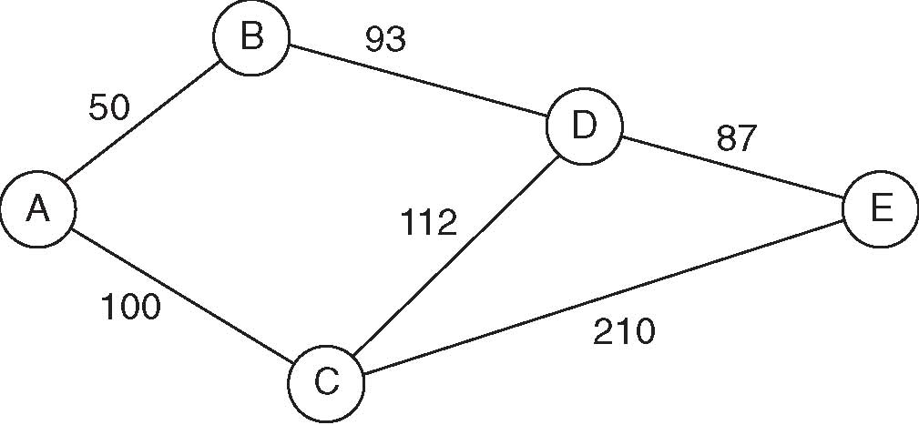
yields the augmented path matrix shown below.

Vertex list |  | Path matrix (cost|second vertex on shortest path)
Index | Label | From/To | 0 | 1 | 2 | 3 | 4
0 | A | 0 | 0|0 | 50|1 | 100|2 | 143|1 | 230|1
1 | B | 1 | 50|0 | 0|1 | 150|0 | 93|3 | 180|3
2 | C | 2 | 100|0 | 150|0 | 0|2 | 112|3 | 199|3
3 | D | 3 | 143|1 | 93|1 | 112|2 | 0|3 | 87|4
4 | E | 4 | 230|3 | 180|3 | 199|3 | 87|3 | 0|4

Entry (0,4) in this path matrix indicates that the cost of the shortest path from vertex A to vertex E is 230. It further indicates that vertex B (the vertex with index 1) is the second vertex on the shortest path. Thus the shortest path is of the form AB...E.

Explain how you can use this augmented path matrix to list the vertices that lie along the shortest path between a given pair of vertices.

To list the vertices that lie along the shortest path between a given pair of vertices using this augmented path matrix, use the “second vertex on the shortest path” value to find the next vertex, then find the next vertex using the same method, and so on until you get to the end matrix.
For example, for A to E, we first check the matrix for the second vertex from A to E, which is B. Now we have A.B…E. Next check B for the second vertex from B to E, which is D. Now we have A.B.D..E. Now check D for the second vertex from D to E, which is E. Since the second vertex is the end vertex, we stop and conclude the path of A.B.D.E.

Name __________________________________________ Date _______________________
Laboratory 12: Analysis Exercise 2

Section _________________________________________

Give an example of a graph for which no proper coloring can be created using less than five colors (see Programming Exercise 2). Does your example contradict the Four-Color Theorem?

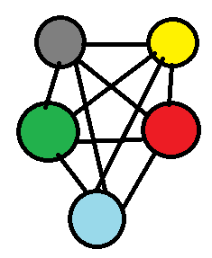
No, it does not contradict the Four-Color Theorem, because the lines are overlapping.

